**HAPPIEST MINDS TECHNOLOGIES LTD.**

**Online Higher Education System Proposal for MSIL India Limited.**



S

**Copyright Information**

This document is the exclusive property of Happiest Minds Technologies Ltd. (“Happiest Minds”). The recipient agrees that they may not copy, transmit, use, or disclose the confidential and proprietary information in this document by any means without the expressed and written consent of Happiest Minds. By accepting a copy, the recipient agrees to adhere to these conditions to the confidentiality of Happiest Minds practices and procedures.

**Confidentiality Clause**

This document is being submitted to MSIL Enterprises Ltd by Happiest Minds Technologies Ltd. on the understanding that the contents of this document will not be divulged to any third party without the express written consent of the parties. It is also understood that the parties will not divulge any confidential information about MSIL that it may have access to during this interaction.

**Disclaimer**

This document has been prepared based on the information provided by MSILL. Wherever proposed, the solutions and/or services mentioned are based on the requirements defined and understood by us at the time of preparing this document. While every effort has been made to make this document as accurate as possible, there might be changes to the document based on the subsequent discussions.

Table of Contents

1. Executive Summary 3

2. Requirement Details 3

2.1 Requirement 3

2.2 In Scope 4

2.3 Out of Scope 5

2.4 Supported OS and Browser versions 5

2.5 Supported Screen Resolution 5

2.6 Assumptions 5

2.7 Dependencies on MSIL 6

3. Solution Consideration 6

3.1 Solution Architecture 6

3.2 Testing and Validation 10

3.3 Proposed DevOps Approach 12

3.4 Technology Stack – Indicative 12

4. Project Delivery Approach 13

4.1 Governance Model 15

4.2 Execution Schedules And Deliverables 15

4.3 Project Communication Model 15

4.4 Risk and Mitigation Plan 16

4.5 Execution Schedule and Deliverables 16

4.6 Change Request Management 17

4.7 Acceptance Criteria 18

5. Commercials 19

# Executive Summary

Happiest minds would like to thank MSIL for giving us this opportunity to bid for Online Higher Education System development RFP. MSIL intends to build the platform to automate process of managing the higher education process for MSIL employees which will improve operational efficiency and better tracking of end-to-end process.

As we understand, the process of managing the higher education process for MSIL employees is completely offline which makes it difficult for respective team members to track each nomination. It also results in higher chances of delay as well as incorrect recovery amount from an employee. The objective of this project is to digitize the higher education application process. The end-to-end process should also enable online soft signing of service agreement. Additionally, the preparation and tracking of recovery schedule will also be automated.

Based on our experience of having collaborations with multiple customers in a similar domain, we believe that Happiest minds would provide an effective solution to full fill the gaps between the logistic vendors.

Happiest minds are excited to bid for this RFP from MSIL and we believe that Happiest Minds is well placed to be the partner of choice for MSIL.

# Requirement Details



## Requirement

The online higher education system will have the following role/personas.

* GTS User
* Employee (nominee)
* Approver (nominee manager)

The following table covers the modules and features planned in phase 1 & 2 implementation. The requirement has been extracted from the BRD and Wireframes (phase 1) shared by MSIL. Since the phase 2 requirement wireframe was not available hence the requirement was defined based on the BRD document and the discussion with MSIL team.



**Phase 1 Requirement**

|  |  |
| --- | --- |
| Module | Features |
| Authentication, Authorization and User Management |  |
| Login |
| Authentication |
| User management (CRUD) |
| Authorization (RBAC – API & UI) |
| GTS Dashboard |  |
| Nomination Dashboard (includes Export to Excel) |
| Add new nominations |
| Admission Dashboard (includes Export to Excel) |
| Publish results |
| Add admission list |
| Employee Dashboard |  |
| New nomination request |
| Admission Acceptance |
| Service Agreement |
| Upload service agreement |
| Approver Dashboard |  |
| Approve Nomination Request |
| User Dashboard |  |
| Request list |
| Email Triggers |  |
| Nomination |
| Publish Result |
| Admission Acceptance |
| Approver Notification |

**Phase 2**

|  |  |
| --- | --- |
| **Module** | **Features** |
| Integration with SAP HR |  |
|  | Get nomination list |
| GTS Dashboard |  |
|  | View detailed request (Track Recovery Schedule) |
|  | Get recovery information (integration with SAP Finance) |
|  | Upload Recovery Schedule |
|  | Calculate Pre-Closure Amount |
|  | Download Service Agreement |
|  | Close Request |
|  | Upload invoice on system |

**Integrations Planned**

* MSIL Identity management
* SAP HR (pull data) integration to fetch the nomination list.
* SAP Finance (pull data) integration to fetch the recovery data.

## In Scope

* Design and Development of Web Portal
* Integration with SAP HR and Finance (Only the eligible nomination list and employee salary recovery information will be pulled from SAP).)
* User Experience (UX)
* Functional Testing
* Application Security
* Performance Testing (2-3 key services only)
* UAT Support of 1 Week
* Support for English Language only
* Setup the Infrastructure on AWS cloud (2 environments) along with MSIL DEVOPS team

## Out of Scope

* Changes in SAP HR and Finance systems
* Requirement
  + Pushing any data to SAP HR and Finance Systems
  + No provision to create User roles through UI or API. There will be pre-defined user roles (employee, GTS, etc.) which will be directly seeded into the database.
  + No individual nomination create/update/delete operations.
* Existing Data Migration or upload
* Test Automation (API and UI)
* PEN Testing
* User Interface responsive to mobile devices
* User Manual, SOP, Runbook
* Warranty Support
* Infrastructure automation
* Any tool/ third party integration other than mentioned on the requirement section.
* Any items not mentioned in the “In Scope” section.

## Supported OS and Browser versions

The user interface will be supported and tested on the “latest Major.Minor version and Major.Minor– 1” at the start of the project for the following browsers:

|  |  |
| --- | --- |
| **Browser** | **Windows Desktop OS version** |
| Google’s Chrome | Windows 10 |
| Firefox | Windows 10 |

## Supported Screen Resolution

The below mentioned screen resolution will be supported for Web application:

* Resolution equal to or above 1280 x 768 pixels (Desktop/Laptop only)

## Assumptions

* Employee manager information will be fetched from MSIL active directory.
* MSIL will provide APIs to fetch the nomination list from SAP HR and recovery information from SAP Finance system.
* One standard Service Agreement format will be used for all scheme, batch, and institutions.
* One standard Recovery Schedule format will be used for a scheme, batch, and institution.
* The emails will be sent from the system for nomination request, publish result, admission acceptance and Nomination Approval to managers. Templates will be provided only for these four scenarios. (Nomination list can only be updated through re-uploading the nomination file.
* There is no edit or delete operations for employee nomination and admission from the UI. The user should upload a new file with the changes for any update or delete.
* There will be a master data of Schemes, Institutes, etc which will be updated as seed data in database.
* Any licensed software if needed will be procured by MSIL.

## Dependencies on MSIL

|  |  |
| --- | --- |
| **Dependency Factors** | **To be available by** |
| Product owner for the knowledge transition of the application, clarification, and review of the user stories | Start of the project |
| Technical SPOC for feedback and clarifications | Start of the project |
| Provide any coding guideline or standards that happiest minds must follow for component implementation | Start of the project |
| Test strategy /plan/ cases shall be reviewed and accepted by MSIL before test execution starts. | As needed during the project |
| Code repository access | Start of the project |
| AWS for create Dev and Production environments | Start of the project |
| UX branding guidelines for User Interface | Start of the project |
| MSIL active director SDK, documentation, and access key for integration | Start of the project |
| SAP HR and Finance API, API documentation and access key in sandbox and production environments for integration | Start of the phase 2 |
| Relevant test data in SAP HR and Finance systems for integration testing | Start of the phase 2 |
| Email template content | As needed during the project |
| Information on the meta data such as User role, Scheme, College | Start of the project |
| Service agreement format and Recovery schedule format | As needed during the project |
|  |  |
| Review UAT Test Case document | As needed during the project |
| Response to Happiest Minds’ queries within two business days. Any delays in response might have an impact on the effort and schedule & will be treated as a Change Request, | As needed during the project |
| Feedback on the deliverables for each milestone must be provided within 3 days of the delivery by Happiest Minds, else, they shall be deemed accepted | During entire project engagement |

# Solution Consideration



## Solution Architecture

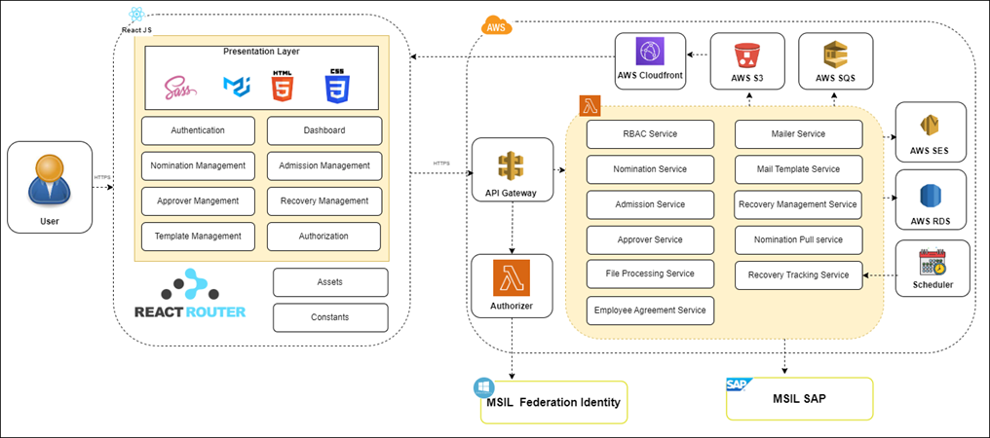

The above architecture diagram depicts high level architecture of the solution. The application will be deployed in AWS Cloud. The following are the major components of the system.

**AWS API Gateway**

AWS API gateway is one of the most popular and flexible API gateways from AWS. This is the gateway of the application, all the traffic to access the application passes through it. All the cross-cutting concerns (Authentication, security, rate limiting, etc.) will be integrated with API gateway. Even though many API gateways are available, we will go with AWS API gateway since our application will be deployed in AWS cloud.

**Authentication**

MSIL already has an identity management system in place which is Active Directory (AD). The proposed system will use MSIL AD for authentication. Authentication with MSIL Active Directory will be integrated with AWS API gateway. Users will log in to the proposed system using the credentials which will be authenticated with MSIL Active Directory. Lambda authorizer will be integrated with AWS API gateway which will interact with MSIL AD to authenticate the user. Once the authentication is successful, a JWT token will be generated which will be used for all subsequent API calls and allow the user to access the resources. In case of unauthorized user or expired JWT, the system will throw an error and redirect to the login screen.

**Microservices**

The application will have well-defined microservices. Since the proposed system does not have a huge number of transactions and the heavy load, the application will have a serverless architecture.

**Consideration for microservices**

* All the REST APIs will be exposed through API gateway.
* All API responses will be in JSON format except file download.
* All list APIs will be provided with server-side pagination.
* APIs will be secured through access token (JWT) which will be passed over the auth header on request.
* All communications are over HTTPS.

The following are the major services.

RBAC Service

Access to the resources will be based on the role of the user. Application will have the provision to allocate the roles for each user. There will be pre-defined roles in the system. Each user will have the role assigned in the system. System checks the role of the user and gives the permissions to access the resources based on the role. The RBAC service will validate the role of the user before it gives access to the user for the resources. The presentation layer will be different for different sets of users based on the role.

If Active Directory can manage the roles of the user, the system will use the existing roles of the user to access the proposed system. It can be finalized during the solution and design phase.

Nomination Service

Nomination service will have well-defined REST APIs. The presentation layer will be integrated with nomination service through REST APIs to perform the necessary actions. All the nomination activities for the course will be handled by the nomination service. The following are the main features of the nomination service.

* GTS team can upload the eligible employees list for the course. In the first phase, it will be a manual file uploaded by the GTS team. In the second phase, the system will integrate with MSIL SAP system to pull the eligible nomination list based on the filter criteria.
* In case of file upload, the system will parse the content from the file and store it in the database.
* In case of pulling the nomination list from SAP, there will be a provision to define the filter criteria in the UI. The system will make the MSIL API call to fetch the nomination list based on the filter criteria defined by the user. The nomination list will be stored in the database.
* Search nomination list based on filter criteria.
* Export nomination list.
* Edit or delete the nomination through file re-upload.
* Create new nomination.
* Employees can view the nomination, accept, or reject their nomination.

**Admission Service**

Once the employee accepts the nomination, the admission process will start. This module has the logic for handling all the admission related activities. Admission service will have well-defined REST APIs which will be integrated with presentation layer. Following are the major features of admission service.

1. View the admission list based on the filter criteria.
2. Export admission list
3. Upload admission list. The user will be able to upload the admission list through the UI to the system, the system will parse the content and store it in the database.
4. Publish the results of the eligibility tests. The user can upload the results to the system for a batch, the system will store the results in the database and trigger an email to the employee.
5. Employees can view the eligibility result, accept, or reject the admission.
6. Logic to provide admission to people on the waiting list in case of higher rank employees rejecting the admission.

**Approver Service**

The system will have a provision to create a nomination for the employee for a scheme. The nomination request will go to the reporting manager for approval or rejection of the nomination. The approver manager details will come from MSIL active directory. Approver can accept or reject the nomination request. Approver can also mention comments along with rejection. Approver service will handle all the approval related activities.

**Nomination Pull Service**

In the first phase, the GTS team will upload the eligibility list by uploading the file in the system. This is a manual process. In the second phase, the system will integrate with MSIL SAP system to pull the eligibility list based on the filter criteria. MSIL will provide the API to interact with SAP system. This service will have the logic to integrate with the MSIL SAP system. The user can define the filter criteria in the UI to pull the nomination list from SAP. The system will make the API call to get the nomination list from MSIL SAP.

**Employee Agreement Service**

Once the employee clears the eligibility test and accepts admission, the employee has to sign a service agreement with MSIL. There will be a provision to download the template from the system and sign the agreement and upload the service agreement into the system. This agreement will be stored in the AWS S3 bucket. The service agreement will not be publicly available to anyone. This can be downloaded through the application using valid credentials. The template will be standard for all the employees. There will be placeholders for the dynamic parameters in the template like name of the employee, start date, end date, scheme, institute, etc. This will be filled in by the system while downloading the agreement. All these activities will be handled by the Employee agreement service. The GTS team can download and view the service agreement of the employee.

**Mailer Service**

The responsibility of the mailer service is to send the email to the person concerned. System will send the email in the following cases.

1. Nomination request
2. Admission request
3. Publish the result.
4. Approver accepting or rejecting the nomination request.

The nomination service, admission service and the approver service will trigger the email request which will be pushed to AWS SQS. This will give the flexibility to send the emails in a decoupled way. Mailer service will consume the queue and send email through the AWS SES service.

**Mail Template Service**

This service will have the flexibility to manage the email template which will be used to send the email. Initially it will be a standard template for all the employees or schemes. But in future we can make this into a dynamic template solution (not in scope).

**File Processing Service**

This module will have the logic of extracting the data from the file and pushing it to the database. GTS team can upload the nomination list, admission list, publish the results, invoice, recover schedule, etc. in the system. These files will be processed by the file processing service and the raw file will be pushed to AWS S3 for future reference.

**Recovery Management Service**

This service will have well-defined REST APIs which will be integrated with the presentation layer. Users can upload the recovery schedule and invoice details in the system. The following are the major responsibilities of the Recovery Management Service.

1. Employee recovery schedule list based on the filter criteria.
2. Export the recovery schedule.
3. Provision to view the recovery schedule of each employee.
4. Upload the recovery schedule.
5. Upload the invoice details.
6. Calculate pre-closure amount.
7. Close request

**Recovery Tracking Service**

Once the recovery schedule is uploaded into the system, the finance team will process the schedule and deduct the amount from the salary every month. Recovery tracking service will pull these details from the SAP and push to the local database. There will be a scheduler running in pre-defined time in regular intervals. These will be tracked in the system and will be available for the GTS team to track the recoveries and the amount due.

**Presentation Layer**

Higher education presentation layer will be deployed in AWS S3 bucket along with CloudFront. It is highly available and stores the content at low cost. CloudFront serves the content through edge servers and caches the content that will improve the performance of the application.

Web application and backend server will communicate over HTTPS using REST APIs for exchanging the data. Proposed solution will have the following major components in the presentation layer.

1. Authenticating the user to access the system.
2. Manage the nomination related activities.
3. Different dashboards and screens for different set of users based on the role.
4. Manage admission related activities.
5. Recovery management
6. Approver management
7. User management
8. Role based access.

## Testing and Validation

Happiest Minds will document Test scenarios/cases and perform Functional and API Testing, Regression Testing, Integration Testing and End to End Testing for requirements that has been stated in scope of work.

**Web Application Testing:** As part of testing, covering.

* Functional Testing
* Responsiveness Testing
* Web Services Testing
* UI / Layout Validation Testing
* User Experience Testing
* Performance Testing
* Application Security Testing

**Testing Life Cycle**

Following lifecycle will be followed for Quality Assurance in the E2E QA Team



**Test Cases Writing**: Document all the test cases to be used for execution using the Use Cases or Test Scenarios identified and associating with the Configurations and Data identified in previous steps.

**Test Execution & Defect Reporting**: Execute the test cases as per the identified plan on the version identified for testing. Log any defects found in the process and track as per the Defect Management Guidelines as set by MSIL.

**Final Sign-Off**: Execute all the identified Acceptance Test cases on Target environment as agreed upon between MSIL stakeholders and Happiest Minds team. Obtain sign-off based on meeting the PASS criteria as agreed upon.

**Types of Testing:**

Below mentioned are the various testing types that would be considered during Testing Phase

|  |  |
| --- | --- |
| **Test Methodology** | **Description** |
| Functional Testing | Following functional/API testing will be performed on the various components.   * Validating UI and data sync * Validate the Alters and Notification as applicable. * Validate the API’s and ensure that the implementation is working correctly as expected. * Validate response payload for and correct field names, types, and values. * Validate the performance of selected API’s and ensure it matches with the benchmark value. |
| Regression Testing | Regression testing would be executed as per test cases documented by Happiest Minds on the in-scope features. |
| Integration Testing | Ensure the Integration validation tests performed for integration between different components of each layer.   * Validate the data loaded from the API and UI should match with different set of data used. * Dashboard data should be validated against the API response respectively. |
| UAT Testing | Happiest Minds QA will provide support to corresponding MSIL stakeholder to conduct execution of pre-defined User acceptance scenarios. A dedicated UAT Environment to be provided or provisioned to perform the same   * Ensure applications (In-scope ’ed) are functional and stable * Predefined UAT Scenarios are executed and ensure there are no issues. * Ensure all the integrations are integrated successfully into the business process. |

## Proposed DevOps Approach

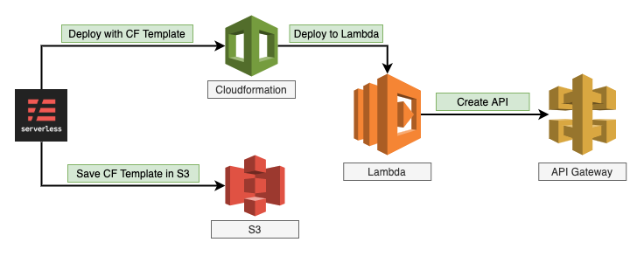

* Cloud Formation template will be initialized for the deployment onto the S3.
* Serverless Lambda function will be configured to push the contents latest onto the S3.
* S3 will be configured with the version control.
* The IAM roles provisioned as part of the policy for the different environments.
* S3 bucket will be configured with the IAM roles for the access for the specific users.
* APIs act as the "front door" for applications to access data, business logic, or functionality from your backend services.
* Lambda will fetch the values and push onto the respective store location in the S3 folder.
* The CloudWatch will be configured for all the monitoring purpose.
* Simple email services, simple queue service and Cloudfront will be configured as part of the deployment.

**Release Process**

* Gates process will be created so that the respective team and the managers approval is obtained.
* Release processes are defined with the CICD Integrated.
* Deployment will be done through the build tool.
* Frequent branches and the tagging process will be created for the deployment.
* Release will be tagged and stored as a Tag in the Repo.
* Hotfix branches will be created during the process of any critical fixes that needs to be part of the deployment.
* Communicate to the Stake holders on the release complete.

**DevOps Cloud Security for Application**

* Access Identity and Management (IAM) Access Analyzer.
* Key Management Service Integrated for encryption.
* S3 configuration and monitoring.
* Security assessments on the firewall rules & configuration from application perspective.
* Access to the corresponding repos.

## Technology Stack – Indicative

|  |  |
| --- | --- |
| **Feature** | **Technology** |
| User Interface | ReactJS, Redux, S3, CloudFront |
| Cloud | AWS |
| API Gateway | AWS API Gateway |
| Microservices | NodeJS, AWS Lambda |
| Messaging Queue | AWS SQS |
| Email Platform | AWS SES |
| Database/Storage | AWS RDS & AWS S3 |
| Authentication & Authorization | MSIL Active Directory, JWT |
| Unit Testing | Jest |
| DevOps | Git, CI/CD, Jenkins |

# Project Delivery Approach

Agile Scrum framework would be used for project execution. Scrum ensures transparency in communication and creates an environment of continuous progress. The below diagram depicts the model followed by Happiest Minds in Agile projects.

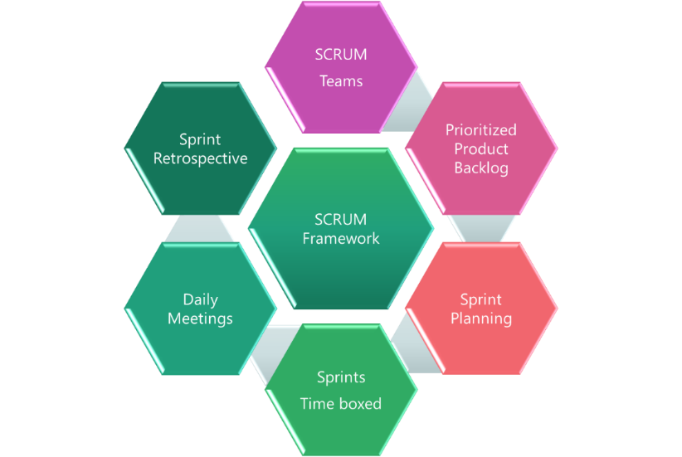

2-week sprint cadence would be followed and there would be a demo at the end of each sprint.



## Governance Model

**Project Communication Model**

The communication model will involve the activities below for successful delivery of the project:

1. **Daily Stand-up meetings**: Between Offshore team and Project manager to discuss tasks completed, task planned and any outstanding blocking issues. MSIL is not required to participate in these meetings, but they are welcome to participate if they want to.
2. **Weekly Status Meeting**: Between Project manager at Happiest Minds and Project manager of MSIL to discuss weekly status report and next week’s plan, issues, risk on the on-going phase of the project.
3. **Monthly Operational Meeting**: Between Delivery Manager and Project Manager at Happiest Minds and Project sponsor at MSIL to discuss progress on the project, issues, and risk with resolution for project delivery and commercials. Monthly meetings can be planned if there are plans to continue further enhancements of this MVP.

## Execution Schedules And Deliverables

The delivery schedule is based on our current understanding of requirements. Any changes in scope of the project can have an impact on the cost and schedule of the project.

The project is estimated to be executed in 6 weeks. Happiest Minds proposes to execute the project in sprint-wise execution. Every sprint will be followed by a Sprint Demo. The project plan in terms of what will be delivered in each sprint will be agreed with MSIL before the start of the project.

## Project Communication Model

Happiest Minds proposes the following project-related communication and their frequency:

* Weekly Status Report shall be shared with MSIL at the end of each week along with the planned set of activities for next week.
* Weekly sync up meeting between the MSIL and Happiest Minds project teams to review the progress of the project
* Quarterly Business review meeting for overall engagement update, roadmaps and opportunity discussion which can be attended by MSIL Sponsor, Executives & respective Directors. Quarterly reviews can be planned once there is confirmation to further enhance the MVP1.

## Risk and Mitigation Plan

| **No** | **Risk** | **Mitigation** |
| --- | --- | --- |
| 1 | We have defined and estimated the phase 2 requirements based on the limited information provided in BRD and discussion with MSIL. Any deviation in features defined in the requirement section, would have impact on the effort and timeline. | Would recommend creating the wireframes of the phase 2 requirements in the first 2 weeks of the project initiation, so that happiest minds team can do an effort estimation. Any deviation requirement and effort, would be taken through change management process. |
| 2 | As the phase 2 timeline is very stringent, any delay in providing SAP HR and Finance API, Contract information and Sandbox environment would impact the delivery schedule and effort | It is expected that these information’s (SAP HR and Finance API, contract information, API access token and Sandbox environment) shall be made available before the end of phase 1 to mitigate any dependencies or delay |

## Execution Schedule and Deliverables

The delivery schedule is based on our current understanding of requirements. Any changes in scope of the project are expected to have an impact on the cost and schedule of the project.

Following is an indicative plan for the implementation, a detailed one shall be arrived at within the 1st week of the project start and shared with all stakeholders.

**Assume Project Start Date: (T)**

**Phase - 2**

|  |  |  |  |
| --- | --- | --- | --- |
| **Milestone** | **Due Date in Weeks** | **Owner** | **Deliverables** |
| Project Kickoff | T | MSIL & Happiest Minds | * Signed SOW document |
| Requirement, UX and Design | T + 1 | MSIL & Happiest Minds | * Requirement documents * UX Design * Application design and Database schema * Backend Code Setup |
| Development Milestone – 1 | T + 3 | MSIL & Happiest Minds | * API gateway configuration * Authentication, User management and RBAC implementation * Nomination dashboard * Upload eligible nomination list. * Export nomination list * Email template definition for sending the email. * Trigger nomination email * Accept/Reject nomination by employees. * Dev environment setup and CI/CD * Test plan and test cases * Integration testing |
| Development Milestone – 2 | T + 5 | MSIL & Happiest Minds | * Create nomination request. * Approver dashboard * Approve or reject nomination request by manager. * Admission dashboard * Publish results. * Add admission list. * Send admission acceptance mail. * Service agreement download / Upload. * User dashboard * Integration testing |
| UAT | T + 6 | MSIL & Happiest Minds | * UAT reports * Bug Fixes |

**Phase - 2**

|  |  |  |  |
| --- | --- | --- | --- |
| **Milestone** | **Due Date in Weeks** | **Owner** | **Deliverables** |
| Project Kickoff | T | MSIL & Happiest Minds | * Signed SOW document |
| Development Milestone – 1 | T + 2 | MSIL & Happiest Minds | * Get nomination list from SAP based on filter criteria. * Upload recovery schedule * Upload invoice details * Employee recovery schedule list based on filter criteria. * Export recovery schedule * Test plan and test cases * Integration testing |
| Development Milestone – 2 | T + 4 | MSIL & Happiest Minds | * Get recovery information from SAP. * Detailed view of the recovery schedule for employee * Download service agreement. * Calculate pre-closure amount. * Close request * Integration testing |
| UAT | T + 5 | MSIL & Happiest Minds | * UAT reports * Bug Fixes |

**Note**: UAT should be completed within 1 week from the delivery of the system tested application. Any further time needed shall go through the change management process.

## Change Request Management

Changes to the scope will mean any of the following:

* Change introduced in the application between the proposal and the actual implementation or during the implementation.
* Any changes to the scope of the project as detailed in section “In Scope”.
* Invalidation of any of the assumptions detailed in section “Assumptions”.
* Any change to the terms and conditions as defined in section “Commercials”.
* Non-fulfillment of any of the dependencies detailed in the sections “Dependencies”.
* Any delay that happens to the schedule can be attributed to MSIL.

In case of a change request, the scheduled end date for this Project and/or the fees associated may change. Whenever a change is identified, it will be managed as per the below process:

* For any changes to the scope, either MSIL or Happiest Minds will submit a Change Request
* Happiest Minds will issue a Change Order providing the impact of the change to the schedule and/or fees.
* MSIL SPOC will review along with Happiest Minds SPOC and mutually agree to either approve or cancel the change order.
* Changes will be implemented only after MSIL SPOC approval and signing of the change order form by both the Parties
* For any MSIL dependencies that are not met or issues that are not resolved, which could impact the schedule – Happiest Minds Project Manager will complete a Change Order and inform the MSIL SPOC.

## Acceptance Criteria

* The user story’s acceptance criteria/test cases will be reviewed and mutually agreed upon.
* The Acceptance test case document along with acceptance test environment details would be shared by MSIL and signed off 4 weeks before the start of Acceptance Testing
* Acceptance Testing will be carried out by MSIL team and supported by happiest minds
* Acceptance Testing should be completed within 2 weeks from the delivery of the system tested application
* The acceptance criteria will be passing of the user acceptance test cases with Zero Critical (P0) and High (P1) severity bugs identified

**Defect Severity – Definition:** Definition of Defect Severity and Priority are as below.

|  |  |
| --- | --- |
| **Defect Severity** | **Definition** |
| P0 – Critical | Defect may be a showstopper – that is, it stops the user from using the system further. |
| P1 – High | Defect occurs repeatedly and prevent the user from proceeding in the normal way, but a workaround exists. |
| P2 – Medium | A defect is isolated or does not stop the user from proceeding but is annoying and causing inconvenience. |
| P3 – Low | A defect that in no way affects the performance or functionality. E.g.: Aesthetic issues and grammatical errors in messages. |

* The deliverables would be deemed accepted if there is no response/feedback from MSIL within 2 weeks post release of System Tested Application.

# Commercials

|  |  |
| --- | --- |
| **Description- Development** | **Amount (INR)** |
|  |  |

* Travel: If any travel and boarding/lodging related expenses are incurred during the execution of the project, it will be charged on actuals to MSIL. Happiest Minds will seek prior permission from MSIL before undertaking any such trip.
* Project specific Costs and Expenses: Happiest Minds will provide standard Microsoft Windows based PC hardware and software to its team members at its site for execution of work under this project. Any project specific specialized hardware, software licenses, testing devices or networking/cloud infrastructure required for the project will either be provided by MSIL or will be procured and expensed to MSIL. Happiest Minds will obtain prior written approval from MSIL before procuring or incurring any project specific hardware, software, devices, or network infrastructure expenditure.
* Taxes: The pricing mentioned excludes GST and any other local and country specific taxes including any withholding tax, as may be applicable.
* Project Timeline: The project is envisioned to be completed in a period of 7 weeks including UAT.
* Delivery Milestone: We propose a Monthly milestone for deliverables. The detailed deliverable plan will be shared with MSIL before the start of the project.
* Invoicing Schedule: The Invoicing Schedule is structured as per the monthly deliverables (scheduled as follows):

|  |  |  |
| --- | --- | --- |
| **Milestone** | **Indicate Dates in Weeks** | **% Invoicing** |
| Project Kickoff | T (Start of the Project) | 20% |
| Phase -1 Milestone 2 | T + 5 | 40% |
| Phase -2 Milestone 1 | T + 8 | 20% |
| Phase -2 UAT | T + 11 | 20% |

* Payment Term: Payment of invoices shall be in accordance with the terms of the Master Services Agreement